Sign up system

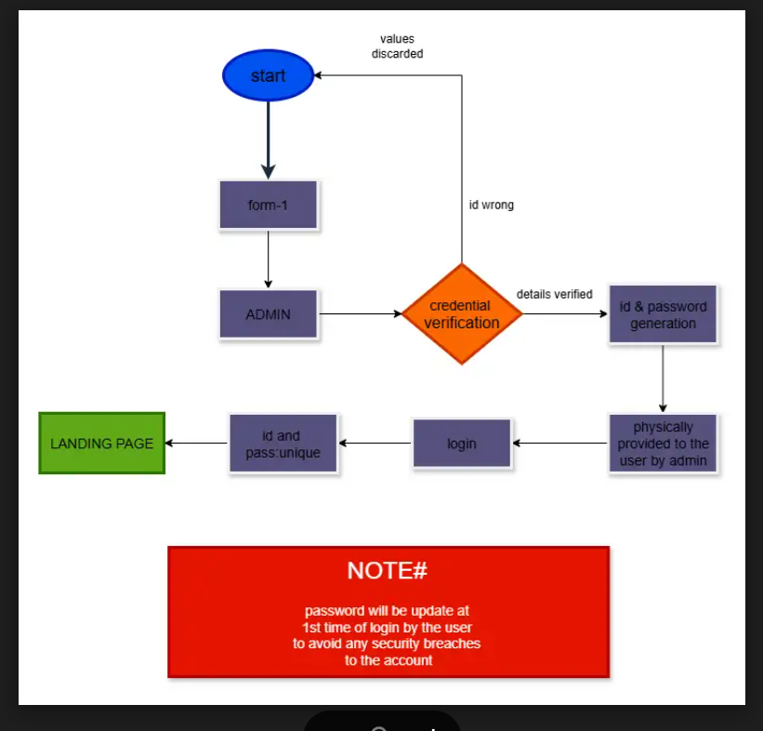

[SIGN UP SYSTEM.drawio - Google Drive](https://drive.google.com/file/d/1n_76ky5rAe-Fq_uNRdtdnWTcPierOFvE/view)